Contents

Introduction 2

Analysis 2

Conclusion 5

# Introduction

The Austin Airbnb market attracts diverse stakeholders with varying interests in understanding its dynamics. Our R Shiny application provides an interactive platform with visualizations and data exploration tools to cater to these stakeholders' needs.

# Analysis

**Price Trends by Month**   
Users can filter by neighborhood and property type to view the average price of Airbnb properties in Austin. I observed that the average price is highest in the month of March. (It is best to avoid Austin in March because of the South by Southwest Festival that month).

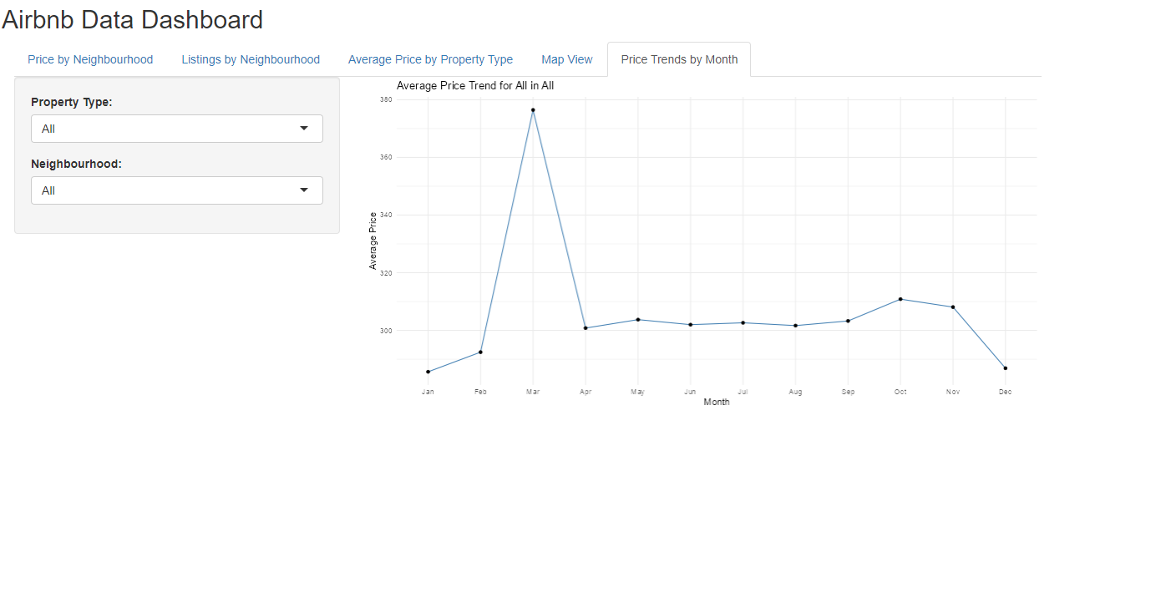

**Price by Neighborhood**   
Scatterplot of neighborhood and price based on reviews category. From this visualization, users can get a comprehensive idea of which neighborhood to choose for their stay in an Airbnb property by looking at the price range and review category.

**Average Price by Property Type**

The bar chart shows the average Airbnb rental prices for different property types (by neighborhood) in East Downtown Austin, with 'Villas' and 'Lofts' being the most expensive and options like 'Boats', 'Dorms', and 'Tents' being the most affordable. The chart helps users quickly compare costs across property types to find a rental that fits their budget.

**Listings by Neighborhood**

This allows users to filter out popular neighborhoods based on their budget and filter based on average reviews received by properties and also wade through the listings based on the review category.

**Average Price by Property Type**

All filters must have an input to view the price and type of the properties in the neighborhood(s) that the user is searching for.

# Conclusion

My R Shiny application provides interactive visualizations and data exploration tools to analyze the Austin Airbnb dataset. It allows users from different backgrounds like potential renters, property owners, and businesses to understand pricing, popular locations, and seasonality trends based on their specific needs.